
Interactive Mapping Interface

User Manual

RADx-rad Data Coordination Center

Version | Date | Comment | By | Checked | Approved
0.1 | June 2021 | Post Beta Testing for Release in June | WCW | ST | HX

Table of Content
1 General Information 2
1.1 Application Overview 2
1.2 Points of Contact 2
2 Application Features 2
2.1 User Account 2
2.1.1 Account Type 2
2.1.2 Create Account 3
2.1.3 Account Status and change Password 3
2.2 Data Dictionary - Before mapping 5
2.2.1 Upload Data Dictionary 5
Step 1: Set up basic Information 5
Step 2: Upload a CSV file 5
Step 3: Share to member 7
2.3 Data Dictionary - Mapping CDE 8
2.3.1 Map variable to CDE 8
2.3.2 Remove Mapping 9
2.3.3 Leave comment 9
2.4 Data Dictionary - Export 10
2.4.1 Export Result 10
2.5 CDE search 10
2.6 Supported CDE collections 11

1 General Information

1.1 Application Overview
The Interactive Mapping Interface (IMI) is a web application that offloads the burden of finding common data elements(CDEs) for Radx project awardees. It provides an interactive user interface and CDE suggestion algorithm that can help researchers to quickly look up CDE candidates for their data dictionary. Awardees can share data dictionaries with their research team to collaborate on the CDE mapping. The supported CDE collections include NIH Minimum CDEs, NIH COVID CDEs and NIH ALL CDEs.

1.2 Points of Contact
For support please contact:
Pritham Ram | pritham.m.ram@uth.tmc.edu
RADx-rad Admin | radx-rad-admin@ucsd.edu

2 Application Features

2.1 User Account

2.1.1 Account Type
There are 3 account type in IMI:
Functions \ Account Type | Data Dictionary Manager | Data Dictionary Member | Reviewer
Upload Data Dictionary | - | √ | √
Add Member to Data Dictionary | - | √ | √
Map Variable to CDE | - | - | -
See All Data Dictionary | √ | √ | -

2.1.2 Create Account
- Visit https://imi.radxrad.org/users/sign_up to create a new account.
- Enter information such as name, email and password
- Data Dictionary Manager should check “I am in charge of the CDE mapping for the following projects” option. Only one person per project.
- Choose RADx-rad projects from the list. If your account doesn’t belong to any of the projects, choose “no project” at the bottom of the page.
- After completing the form, click sign up button and send out the form.
- Please wait for 1-2 days to have your account approved.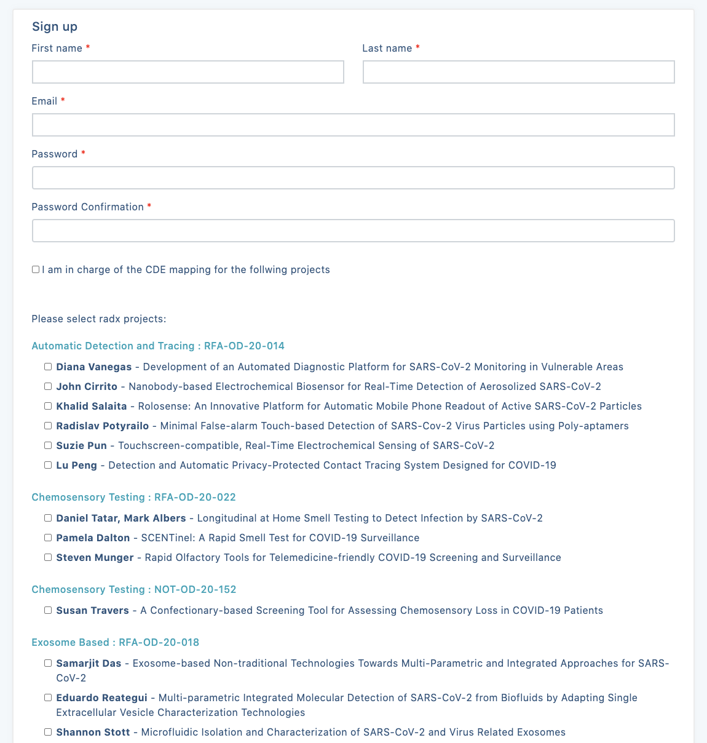
Picture: Sign up form

2.1.3 Account Status and change Password
Once you sign up an account, you can login and click “MY ACCOUNT” on the menu. You can see your account status on this page.
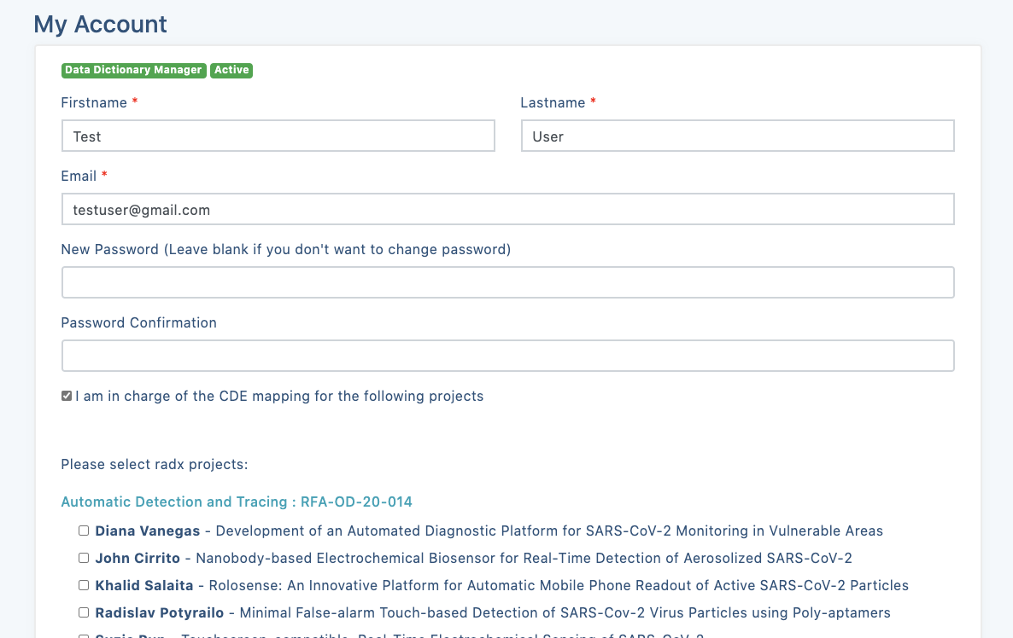
Picture: My account

In this “MY ACCOUNT” page, you can also change your password.

2.2 Data Dictionary - Before mapping

2.2.1 Upload Data Dictionary
Data Dictionary Manager can click the “Upload Data Dictionary” Button on https://imi.radxrad.org/data_dictionaries to initiate the uploading.
Picture: Click the button to start uploading

Step 1: Set up basic Information
In Step one, please enter the Name and Description of this Data Dictionary.
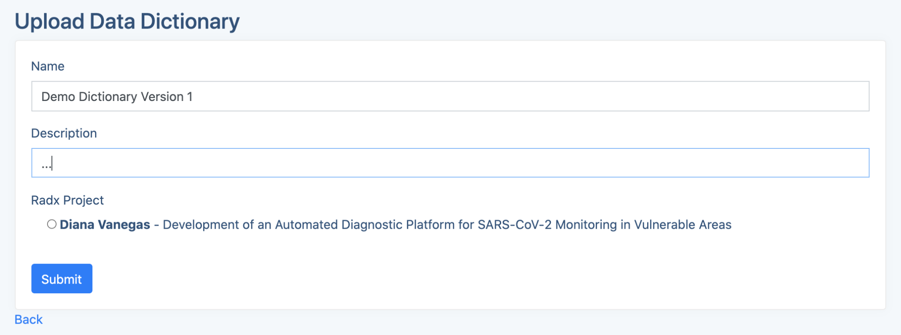
Picture: Basic Information

Step 2: Upload a CSV file
- Once you submit the Step 1 form, you create an empty data dictionary mapping workspace.
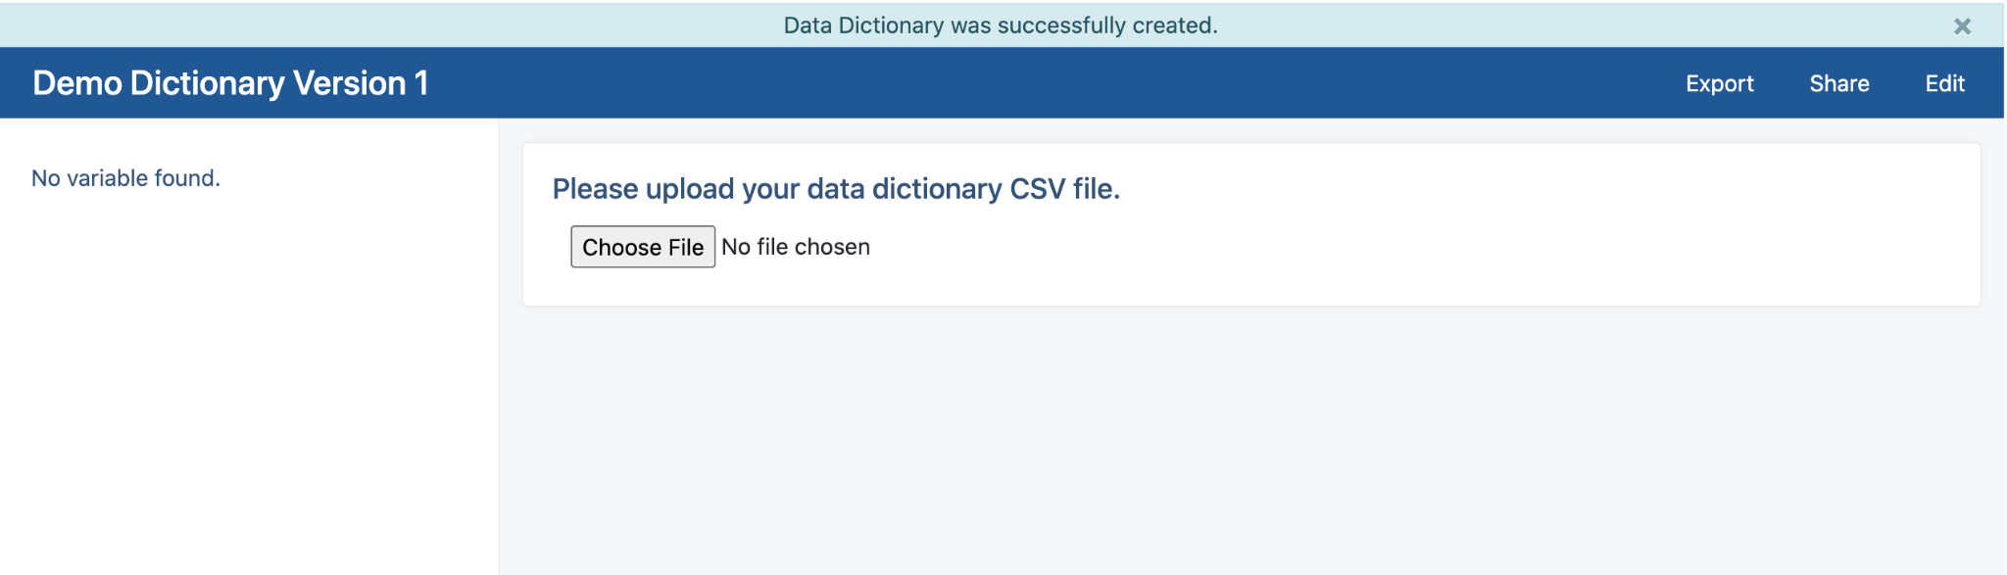
- Click on the “Choose File” to upload your CSV file.
- After uploading the file, the system will ask you to select the name and description column. These two fields will help the search engine to get the suggested CDEs.
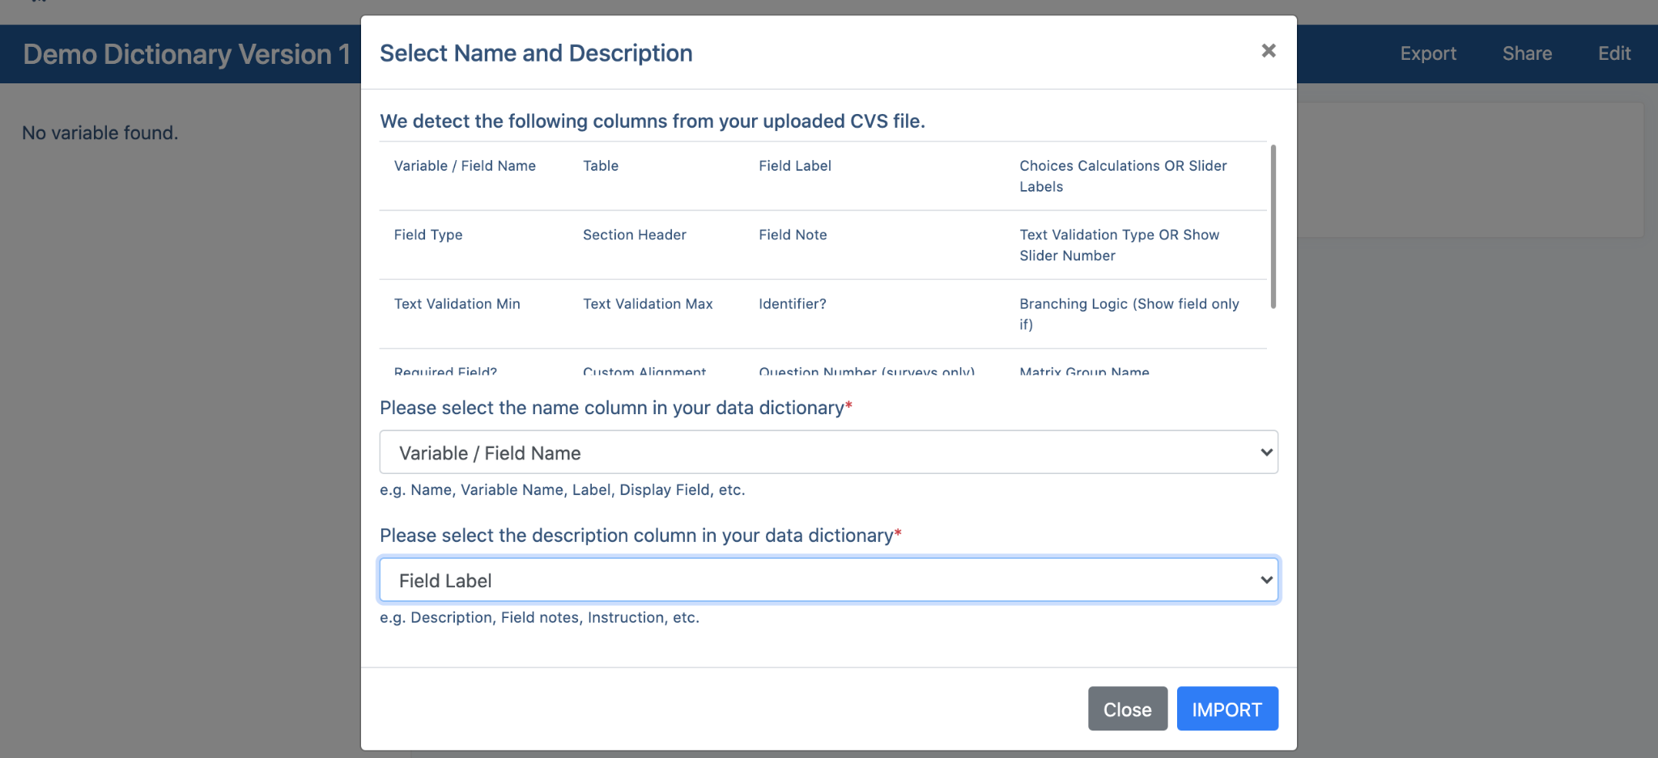
- Click the “IMPORT button” and the system will work on the CDE suggestions in the background. Please come back to this page after you receive a notification email.
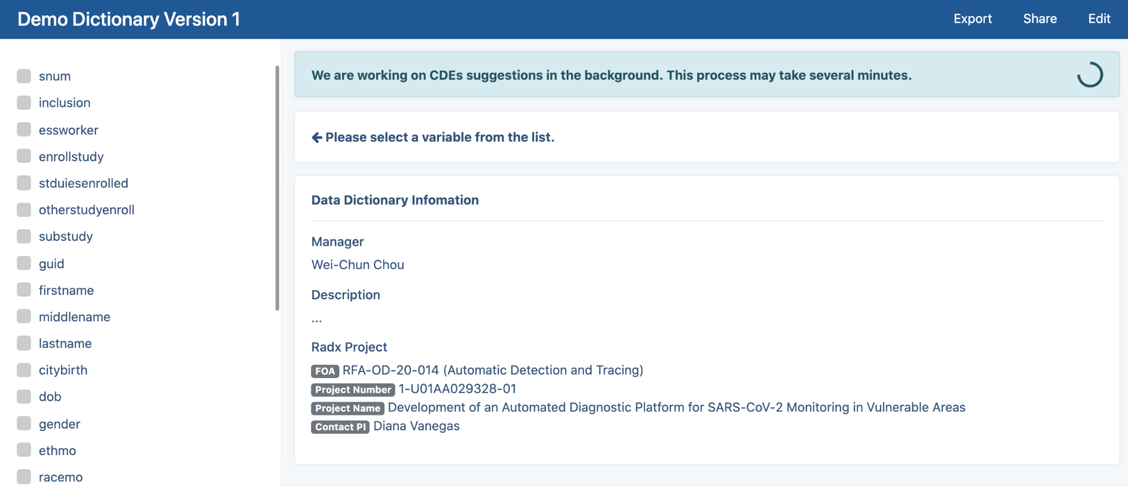

Please don’t refresh this page or re-enter this page before receiving the notification email.

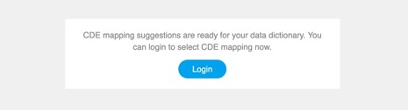
Picture: The email notification when the suggestions are ready.

Step 3: Share to member
If you are a Data Dictionary (?) Manager, You can share this Data Dictionary to other user (members).
- Click the “Share” button on the blue menu bar.
- Select the user you want to share to, set up their privileges, and click the “Share” button.
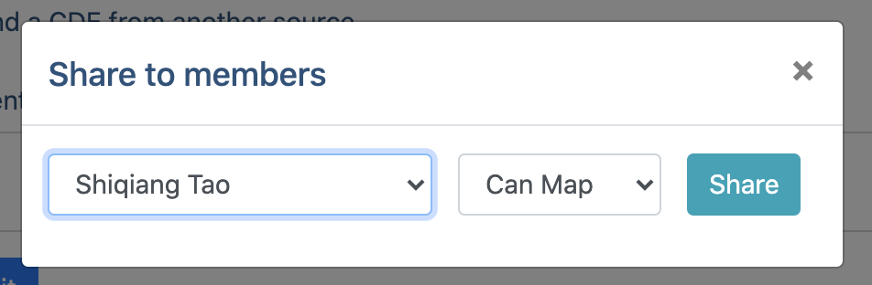
- You can remove members by clicking the trash icon.
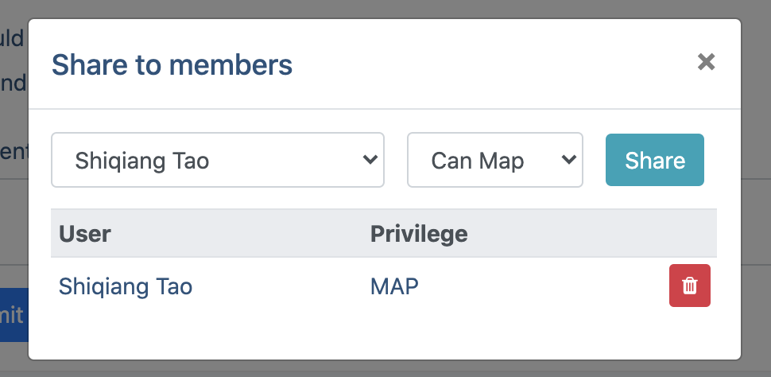

Type of Privileges:
- Can Map: User can select CDE for the variables
- Can Share: User can select CDE for the variables and share this data dictionary to other user

2.3 Data Dictionary - Mapping CDE

If a variable is mapped to a Minimum CDE, then that MUST be selected for use. It is recommended that for those variables not mapped to a Minimum CDE but mapped to COVID-CDEs and other CDEs, the COVID CDE be preferentially selected if it meets the intent of the variable. If the search does not give any results, then it is likely that the variable is not part of the CDE database at NIH (Minimum, COVID, or Collection), and the RADx-rad DCC will work with the researcher to map or develop a structure for the variable. (Section 2.4.3)

2.3.1 Map variable to CDE
- Once the auto-suggestion process is completed, you can click on any variable on the sidebar menu to see the recommended CDEs
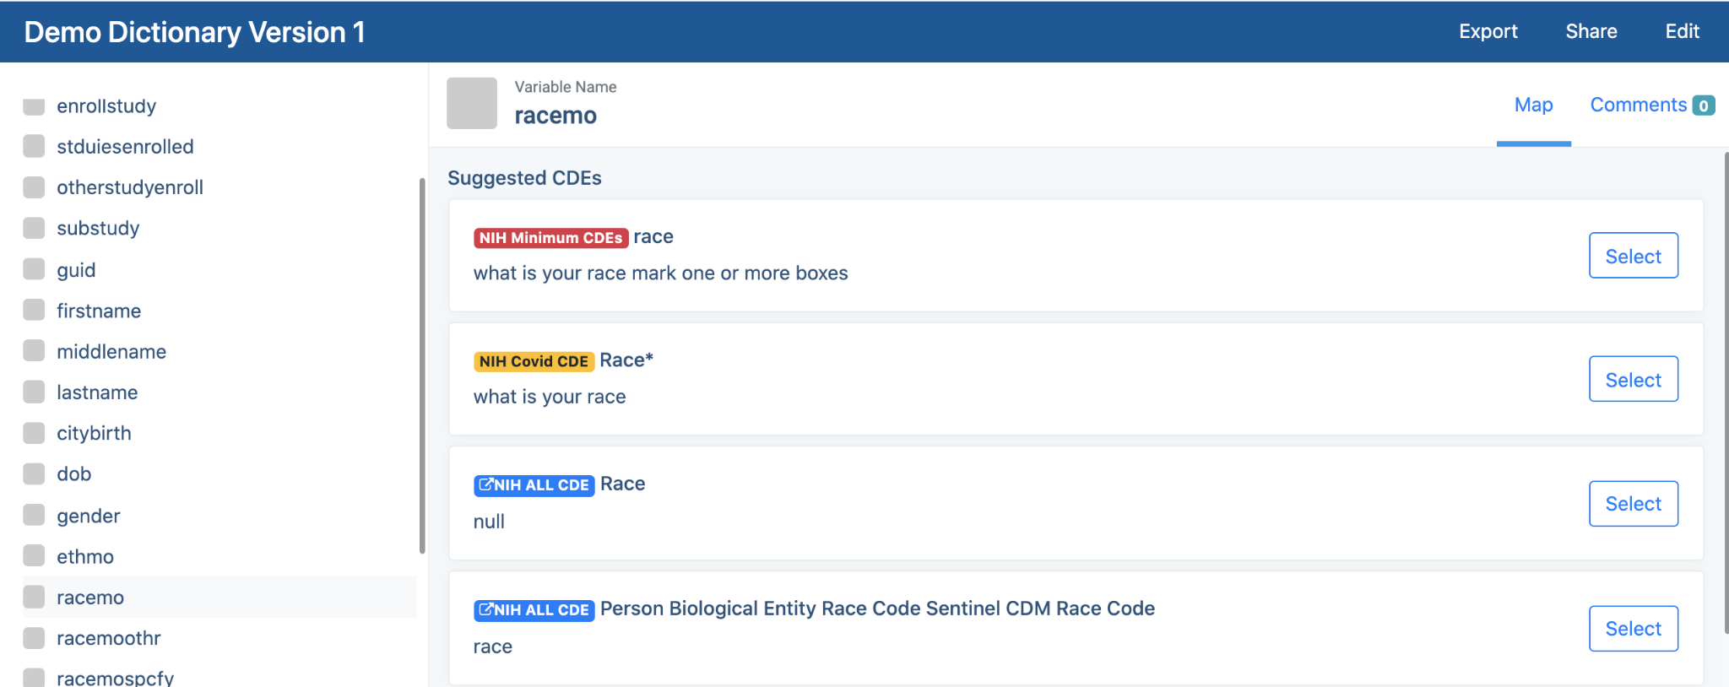
- You can click on the name of the CDE to see the details.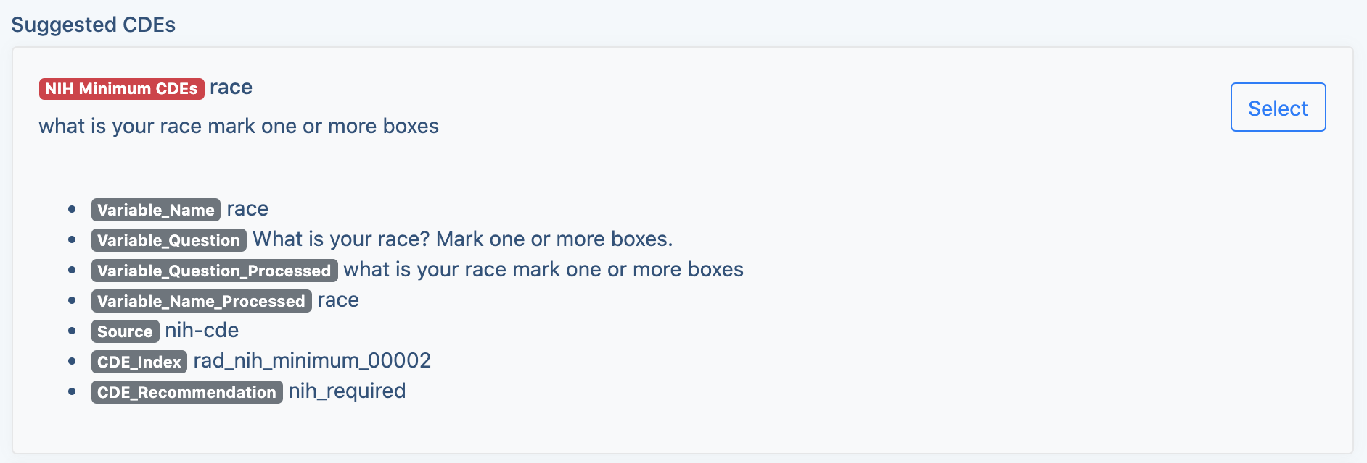
- Click the “Select” button to map the variable to this CDE.
- You will see the mapped CDE on the top of the list.
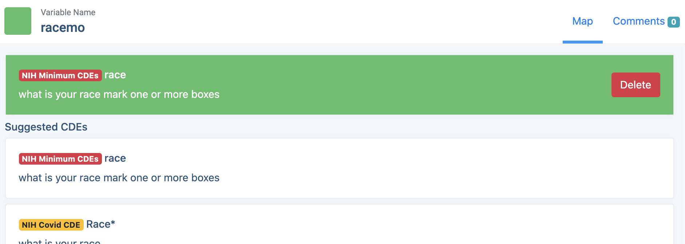

2.3.2 Remove Mapping
Click the “Delete” Button and remove this mapping
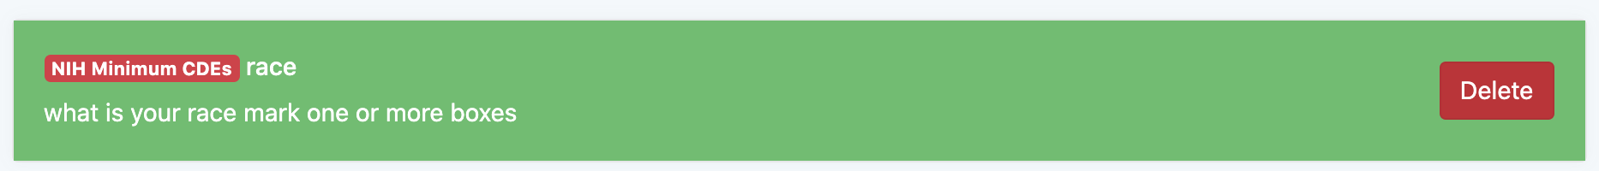

2.3.3 Leave comment
- You can find the comment section by clicking the comment tab in variable menu bar.
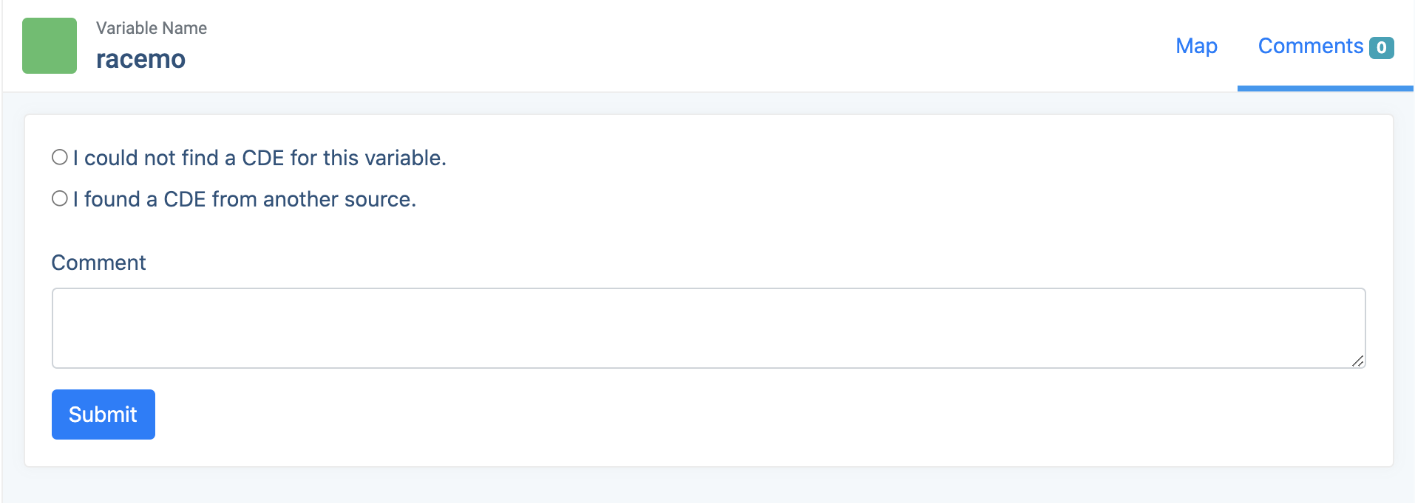
- Choose the type of comment (optional) and leave your message.

2.4 Data Dictionary - Export

2.4.1 Export Result
You can download the result of the mapping in a CSV format by clicking the export button.
The CSV file will display the detail of that variable and the mapped CDE in a row.
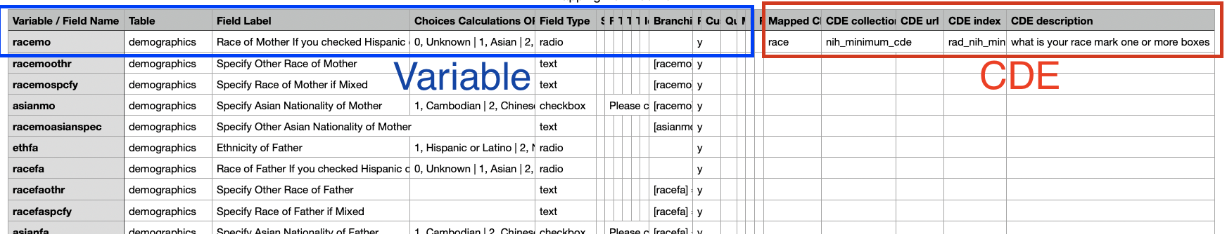

2.5 CDE search
CDE Search (https://imi.radxrad.org/search_cde) is a function that allows users to look up CDEs without uploading any data dictionary.
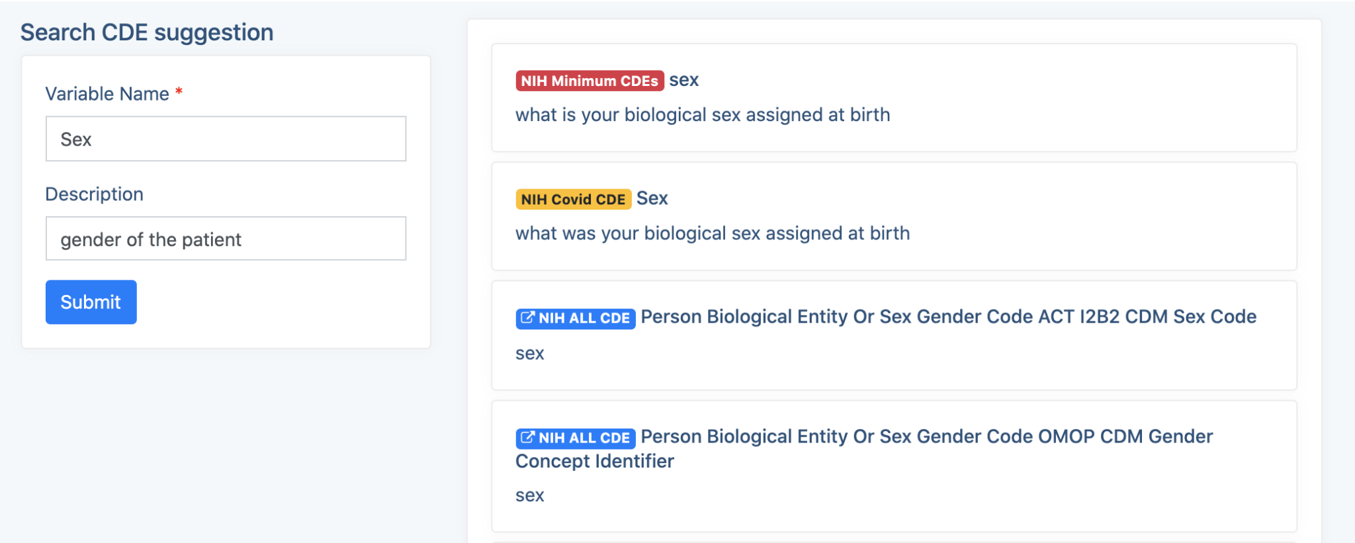
Picture: CDE Search
Enter Variable Name and description you want to look up, and the application will provide you suggested CDE from CDE collections.

Click on the name of the CDE and you can find more details about this CDE
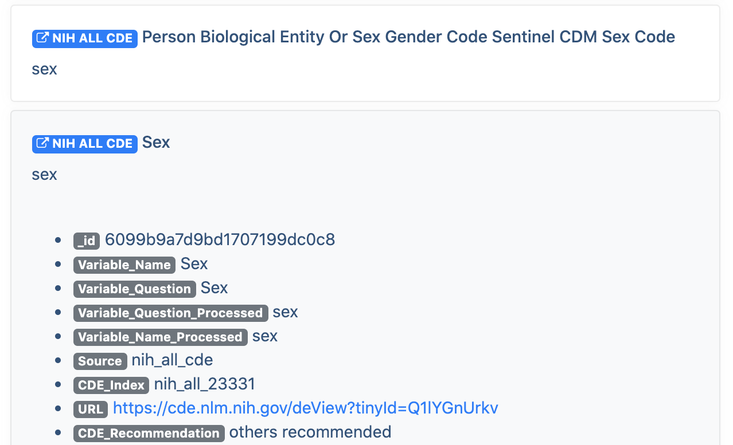

2.6 Supported CDE collections
IMI currently support 3 CDE collections:

NIH Minimum CDEs
The required CDE

NIH COVID CDEs
The CDE that has a higher priority than NIH ALL CDEs

NIH ALL CDEs
The most completed CDE repository provided by NIH. You can find more details here: NIH Common Data Elements (CDE) Repository

